Zoe Savina – Greece 16/4/2020
1)
Zoe Savina’s Book 2019

___The essay " Plentiness Out of Littleness": The Landscape of Haiku in Greece- Haiku: A Spiritual Globalization” was the topic of a lecture I gave at "The Workshop" of the National and Capodistrian University of Athens, Greece, on 16/07/2014 upon the theme: "The Impact Of Japanese Culture In Modern Society", which was also transformed into a printed volume containing all other speakers' works and uploaded also on the online library of "International Haiku Foundation".He was also present electronically in Serbia (English and Serbian), but also by the 2nd University of Paris. It was presented as a university study. It was later requested by a foreign publisher house, to become a book. Here the book was printed in Berlin in 2019. Presented at AMAZON International Market ( AMAZON Plentiness Out of Littleness zoe savina)
Abstract Haiku is a Japanese poetic genre having influenced modern Western culture by its appealing conceptual “abundance” produced through “frugality”. Lafkadio Hearn, a Greek-Irish scholar, translated haiku into English and made it internationally-known. Haiku is vaguely interacted with the ancient Greek epigrammatic genre of “cosmos”, Hesiod’s pastoral poetry and the laconic poetic form of “epigram”.
Keywords Japan, influence, West, abundance, frugality.
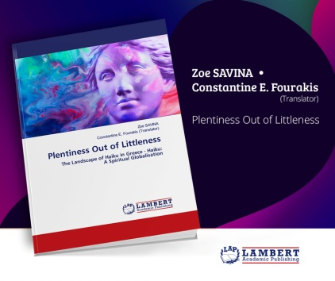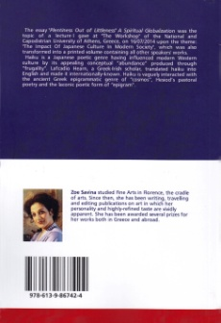
2)
Zoe Savina’s Book 2019

The haiku book " Now I Know ", published by "Gyberwit.net" 2020. A haiku book in 7 sections. Briefly -treason opens with an organized stunning material made of durable threads… The book is bilingual. English and Greek.
In English translation, Constantine Fourakis.
Vignettes by the painter: Alexandros Moustakas.
Available in the international market: AMAZON & GYBERWI.net.
https://www.amazon.com/Now-I-Know-Zoe-Savina/dp/9389690269
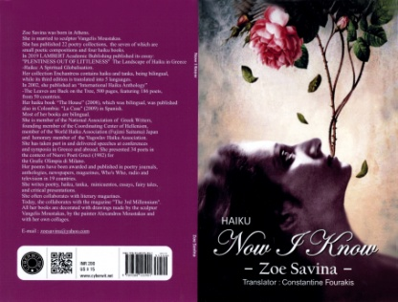

3)
Video 10 Nov.2019 Zoe Savina

He Was Born Again ( Vangelis Katsoulis, Zoe Savina-haiku)
https://www.youtube.com/watch?v=Ogfo5shoBvY
Music composed by Vangelis Katsoulis on Zoe Savina's Subject haiku & collage
English translations by Constantine Fourakis
Japanese translations by Ban’ya Natsuishi
___The exceedingly condensed wording of haiku flows as if it wanted to remind us every time that “one who knows will not speak and one who speaks does not know”. The fact that haiku has been associated with the Zen philosophy is not coincidental. The person who decides to be initiated into Zen has one and sole goal: to reach “satori”, which means “enlightenment”, a situation in which one experiences the world in its maximum wholeness. This unique experience is accomplished only when one manages to “halt”, to “immobilize” time. It is taken for granted that whoever makes haste has no feelings. If we try to “slow down” our rhythms, we will ascertain immediately that the more slowly we move, the more we feel. There is no recipe about how one can reach satori. One may reach it many a time in the most paradoxical way and frequently along a surprisingly simple road: “staring at the flowers of a cherry tree”. Word has been “reborn” in Zoe Savina’s poem from her “Golden Book”, which is devoted to Lafcadio Hearn and, in doing so, she bears witness to this confrontation with common logic in her haiku when she reveals that: “he was born again looking at the flowers of the cherry-tree” I chose one and sole haiku from all of her book and wished to illustrate the substance of the poem and of satori through the sense of time immobilization. However, music also has something common with haiku: it is a small seed from which a very large tree can spring off. Music can hide the whole world within it but it is in immobility and absolute serenity that it acquires the magical power to reveal it.
Vangelis Katsoulis
https://www.youtube.com/watch?v=Ogfo5shoBvY

